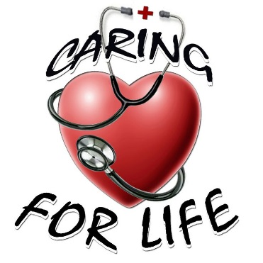
NYS ID/DD Nurses Association
Nomination Form for the
Joyce Binder Memorial Award

The Joyce Binder Memorial Award is given to an outstanding member of the NYS ID/DD Nurses Association who has made a significant contribution to advancing the practice of supporting individuals with ID/DD.
Nominations are accepted throughout the year. Nominations received by July 31 will be eligible for consideration for this year’s Joyce Binder Memorial Award. Nominees must be members of NYS ID/DD Nurses Association for the current year.
Complete this nomination form and save it as a PDF file. Email this nomination form to the NYS ID/DD Nurses Association at information@nysidddna.org.

Nominee Name, Degree, and Title:

Experience of Nominee:

Information about the Nominee:
- Describe how this nurse has/will change the quality of life and has made a positive impact for the people he/she supports. Your response should be 150-500 words.

- Describe the attributes this nominee has demonstrated. Your response should be 150-500 words.
Caring/Compassion • Advocacy, Mentoring • Leadership • Dedication • Education • Research

Name of Nominating Person and Relationship to Nominee

Your Email Address and Phone Number Date Submitted

This form is available on the NYSIDDDNA website (www.nysidddna.org) under the Awards tab.

